Nginx on ubuntu with wordpress

Install nginx

Apt install nginx

Install mysql

Apt install mariadb-server mariadb-client

Setup mariadb

Mysql_secure_installation #give root password

Mysql -u root -p

->create database db_name

->create user “user_name”@”%” indentified by “userpass”

->grant all privileges on db_name to “user_name”@”%”;

->exit

Install php with other php ext.

Apt install php php-gd php-mysql php-curl php-common php-fpm

Install wordpress

Wget <https://wordpress.org/latest.zip>

Unzip latest.zip

cp -r wordpress/* /var/www/html/ngi

mv /var/www/html/index.html /var/www/html/index-org.html

mv /var/www/html/index.nginx-debian.html /var/www/html/index.nginx-debain-org.html

configuring nginx for wordpress

cd /etc/nginx/sites-enabled/

cp default wordpress.conf #making wordpress conf file for nginx

nano wordpress.conf #editing in config file

visit this to get the refences

http://www.nginx.com/nginx-wiki/build/dirhtml/start/topics/recipes/wordpress/

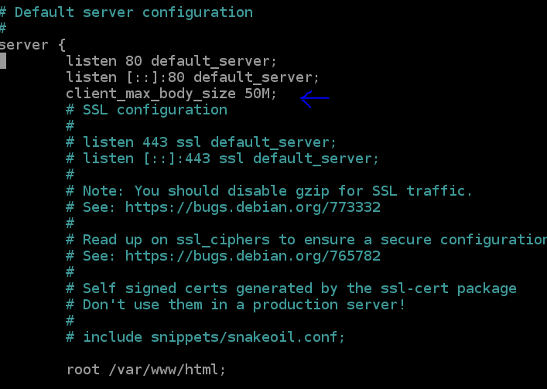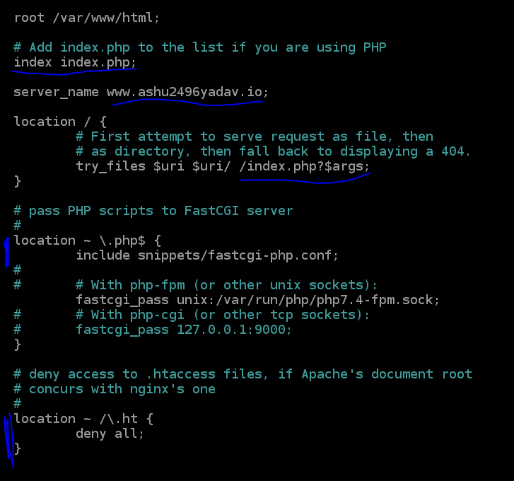

For exceeding the limit of file uploading on our site

after saving config file delete or change name of default file with its link

mv default ref

mv /etc/nginx/sites-available/default /etc/nginx/sites-available/ref

test and restart nginx server

nginx -t

systemctl restart nginx

open web browser and run <http://3.16.129.185/> and futher configure the wordpress and install

[nginx]

172.31.3.78

172.31.2.84